**How to use a Vernier Caliper**

1. 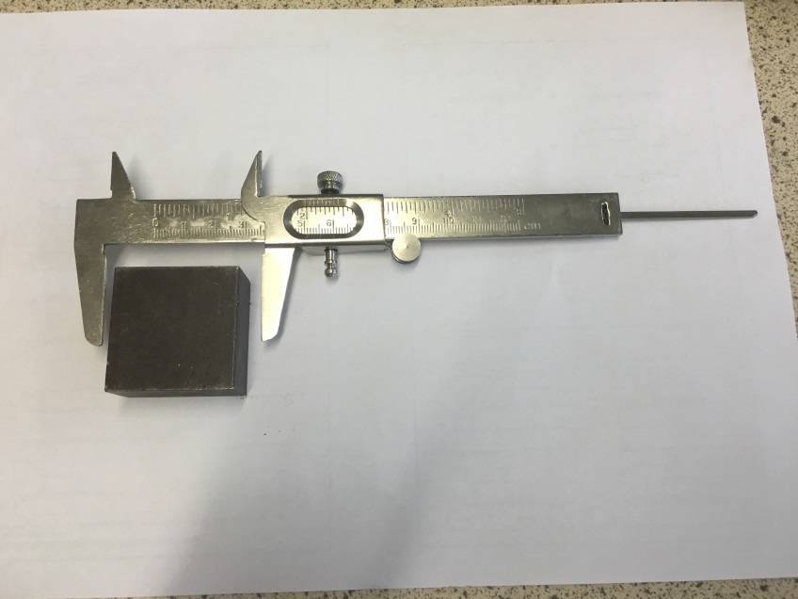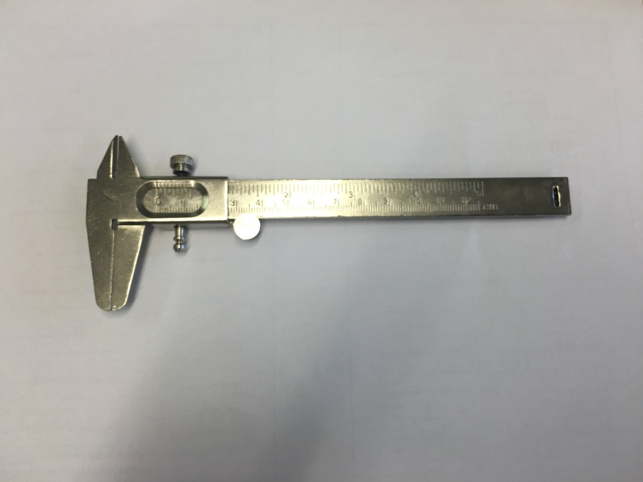First, close the vernier caliper as tightly as possible. If the scale at the top shows that it is measuring 0, then you are ready to begin. If not, then you have a zero error. This error should be added or subtracted from any result that you get. For example, if the zero error was 0.2mm, you would have to subtract 0.2mm from every result to make them all accurate.
2. If you would like to measure the outside of an object, unwind the vernier caliper using the rolling wheel so that it is wider than the object you would like to measure.
3. 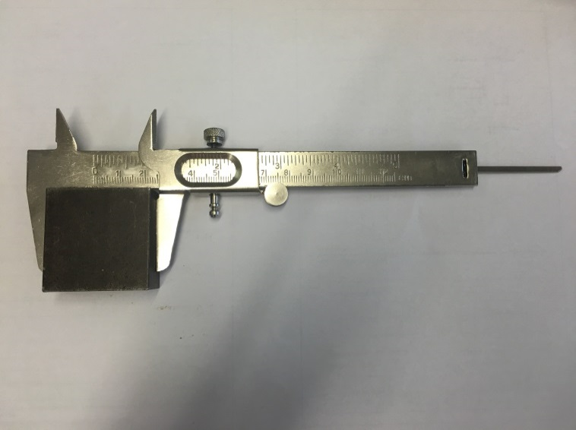Then tighten the jaws until they firmly grip the object.

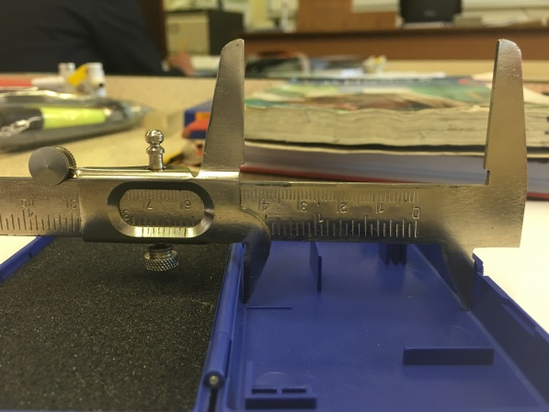

1. To measure the inside of an object, place the smaller jaws on the top of the vernier caliper inside of the object. Open these as far as you can.

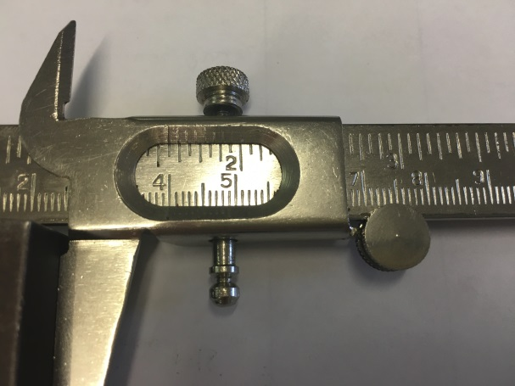

1. Next, read the measurement off of the vernier caliper. To do this, read where the first marking on the bottom of the frame meets the markings on the inside, as shown in the image.

This will give you the length to the nearest tenth of a cm. Then, you find where the next marking on the frame lines up with a marking on the larger scale. This value on the larger scale will give you the nearest hundredth of a cm.

**How to use a Micrometer**

1. 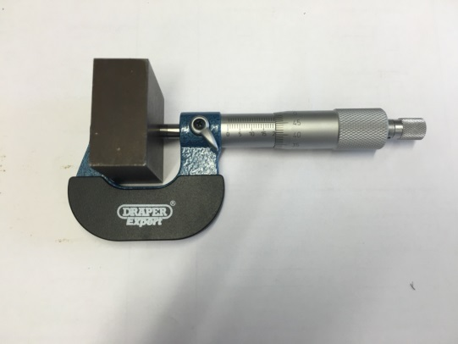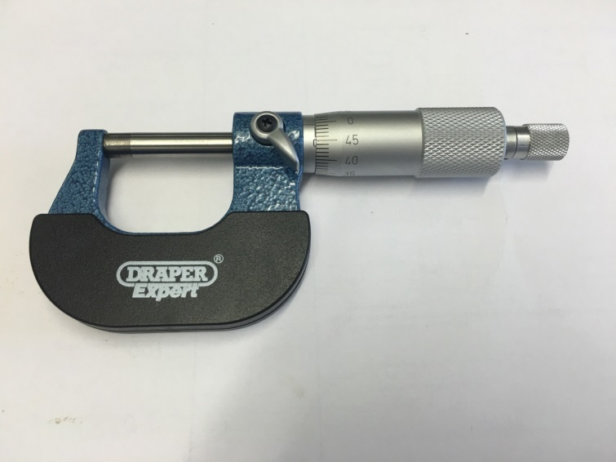First, close the micrometer as tightly as possible. This is done by using the ratchet on the end of the micrometer. This is turned instead of the main body of the micrometer as not to make it too tight. Once it makes a clicking noise, it is tightened. If the line next to 0 on the main body of the micrometer lines up with the 0 on the turnable handle scale, then you are ready to begin. If not, then you have a zero error. This error should be added or subtracted from any result that you get. For example, if the zero error was 0.2mm, you would have to subtract 0.2mm from every result to make them all accurate.
2. Next, you need to unscrew the micrometer so that it is wider than the object that you want to measure. Place the object inside of the micrometer, and then tighten it so that it firmly grips the object.
3. 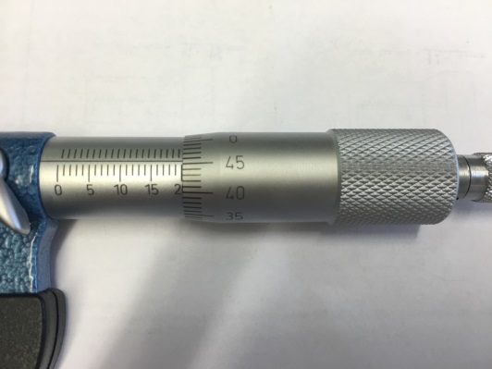Read the measurement on the micrometer. To do this, you first need to read the scale on the main body of the micrometer. Find the last value that you can see, bearing in mind that this may be a half value. This is the size of the object to the nearest mm. Then, the scale on the turnable handle provides the values to a tenth and a hundredth of a mm. If you had a full value on your first scale, you just use the value you measured on the second scale, however, if you measured a half value on your first scale, you need to add 50 the second value that you measured.